**NAAN MUDHAVAN**

**ASSIGNMENT DOCUMENT**

**COURSE TITLE** : DIGITAL MARKETING

**COLLEGE CODE** : 1105

**COLLEGE NAME** : GOJAN SCHOOL OF BUSINESS AND TECHNOLOGY

**NM ID** : 94ADAF9DCE94898A90C48DB66511FE88

**NAME** : DILLI BABU.D

**REGISTER NUMBER** : 110520106002

**YEAR** : 4TH YEAR

**DEPARTMENT** : ELECTRONICS AND COMMUNICATION ENGINEERING

1. Create a blog or website using Blogspot and Wordpress. Customize the theme design and post new article with 500 words.

Link: <https://digitalworld6002.blogspot.com/2023/10/digital-world.html>

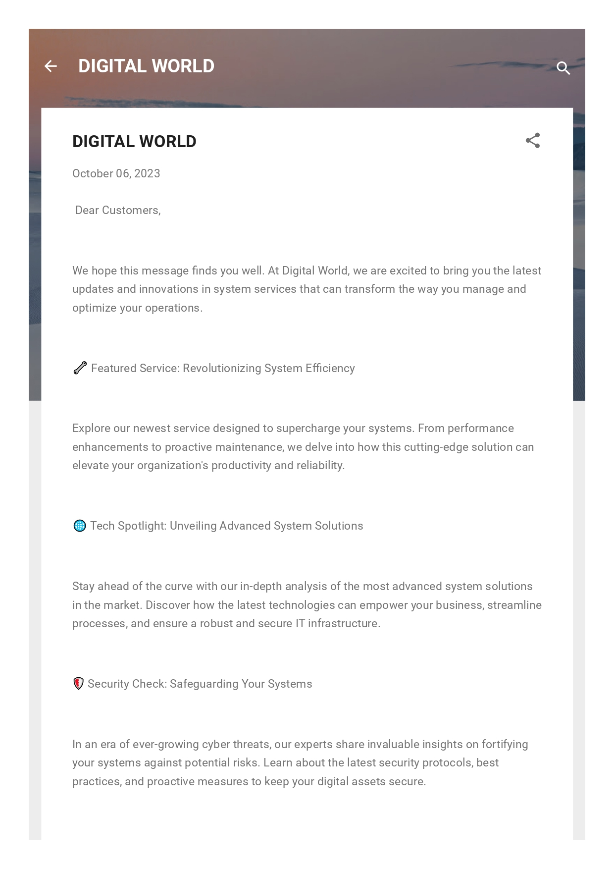

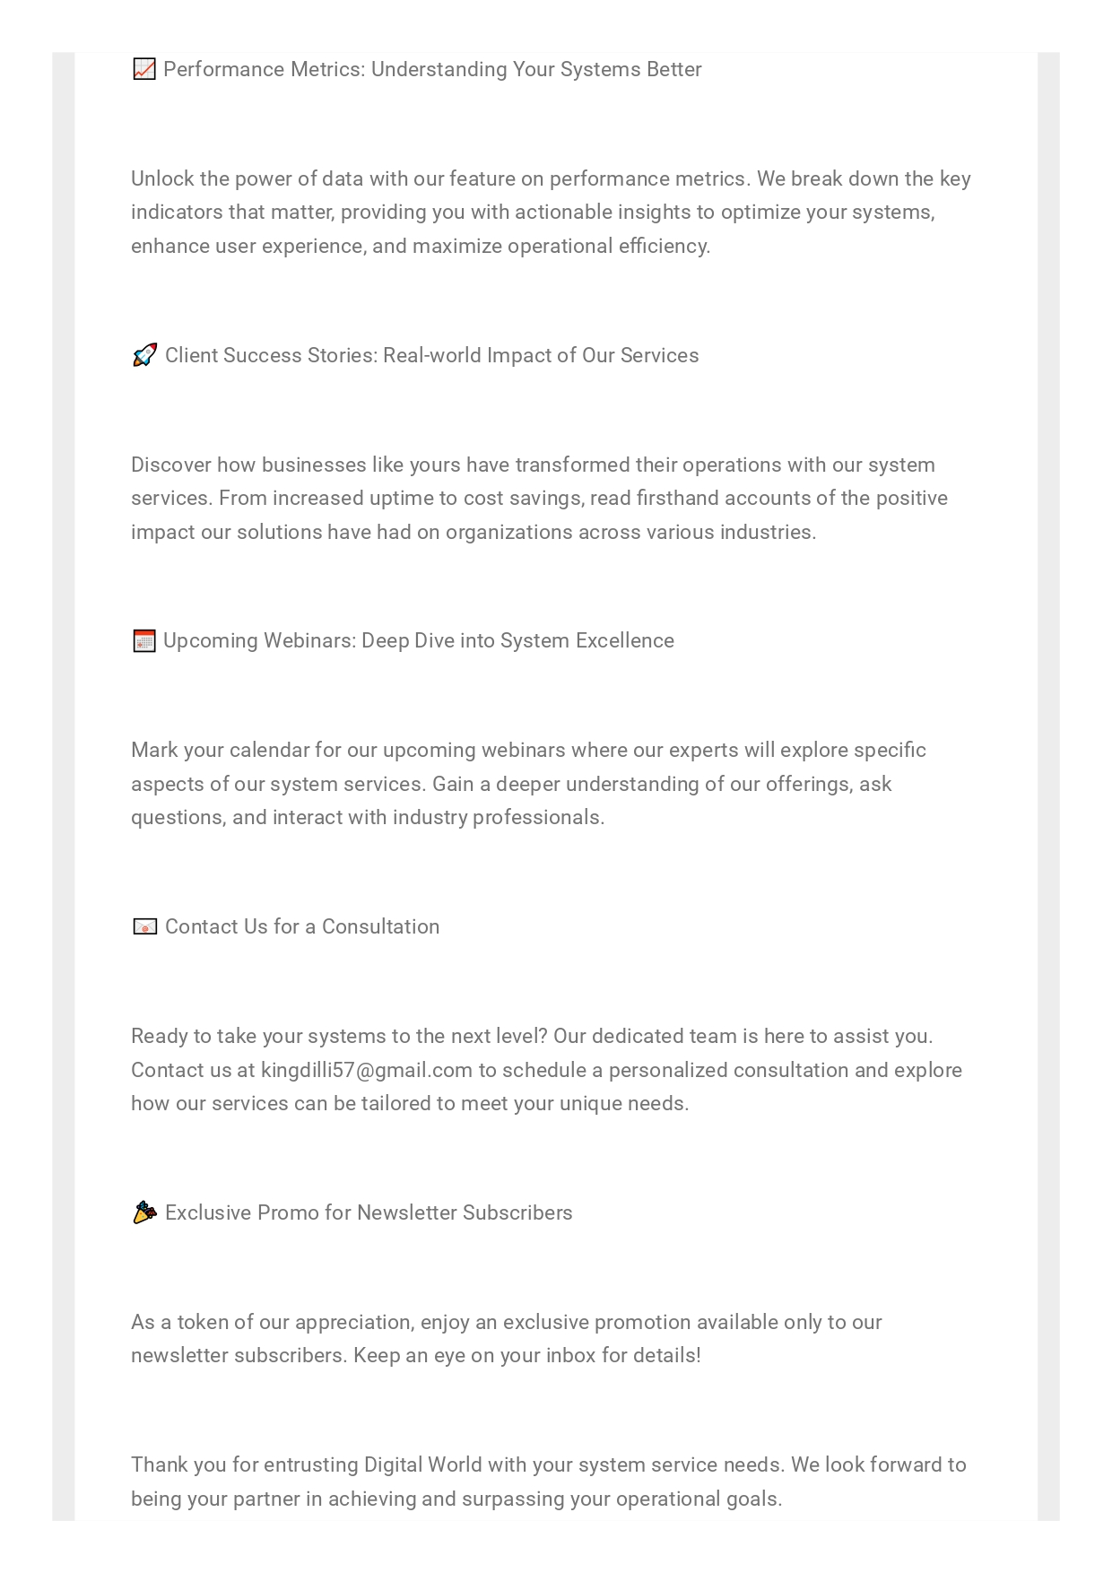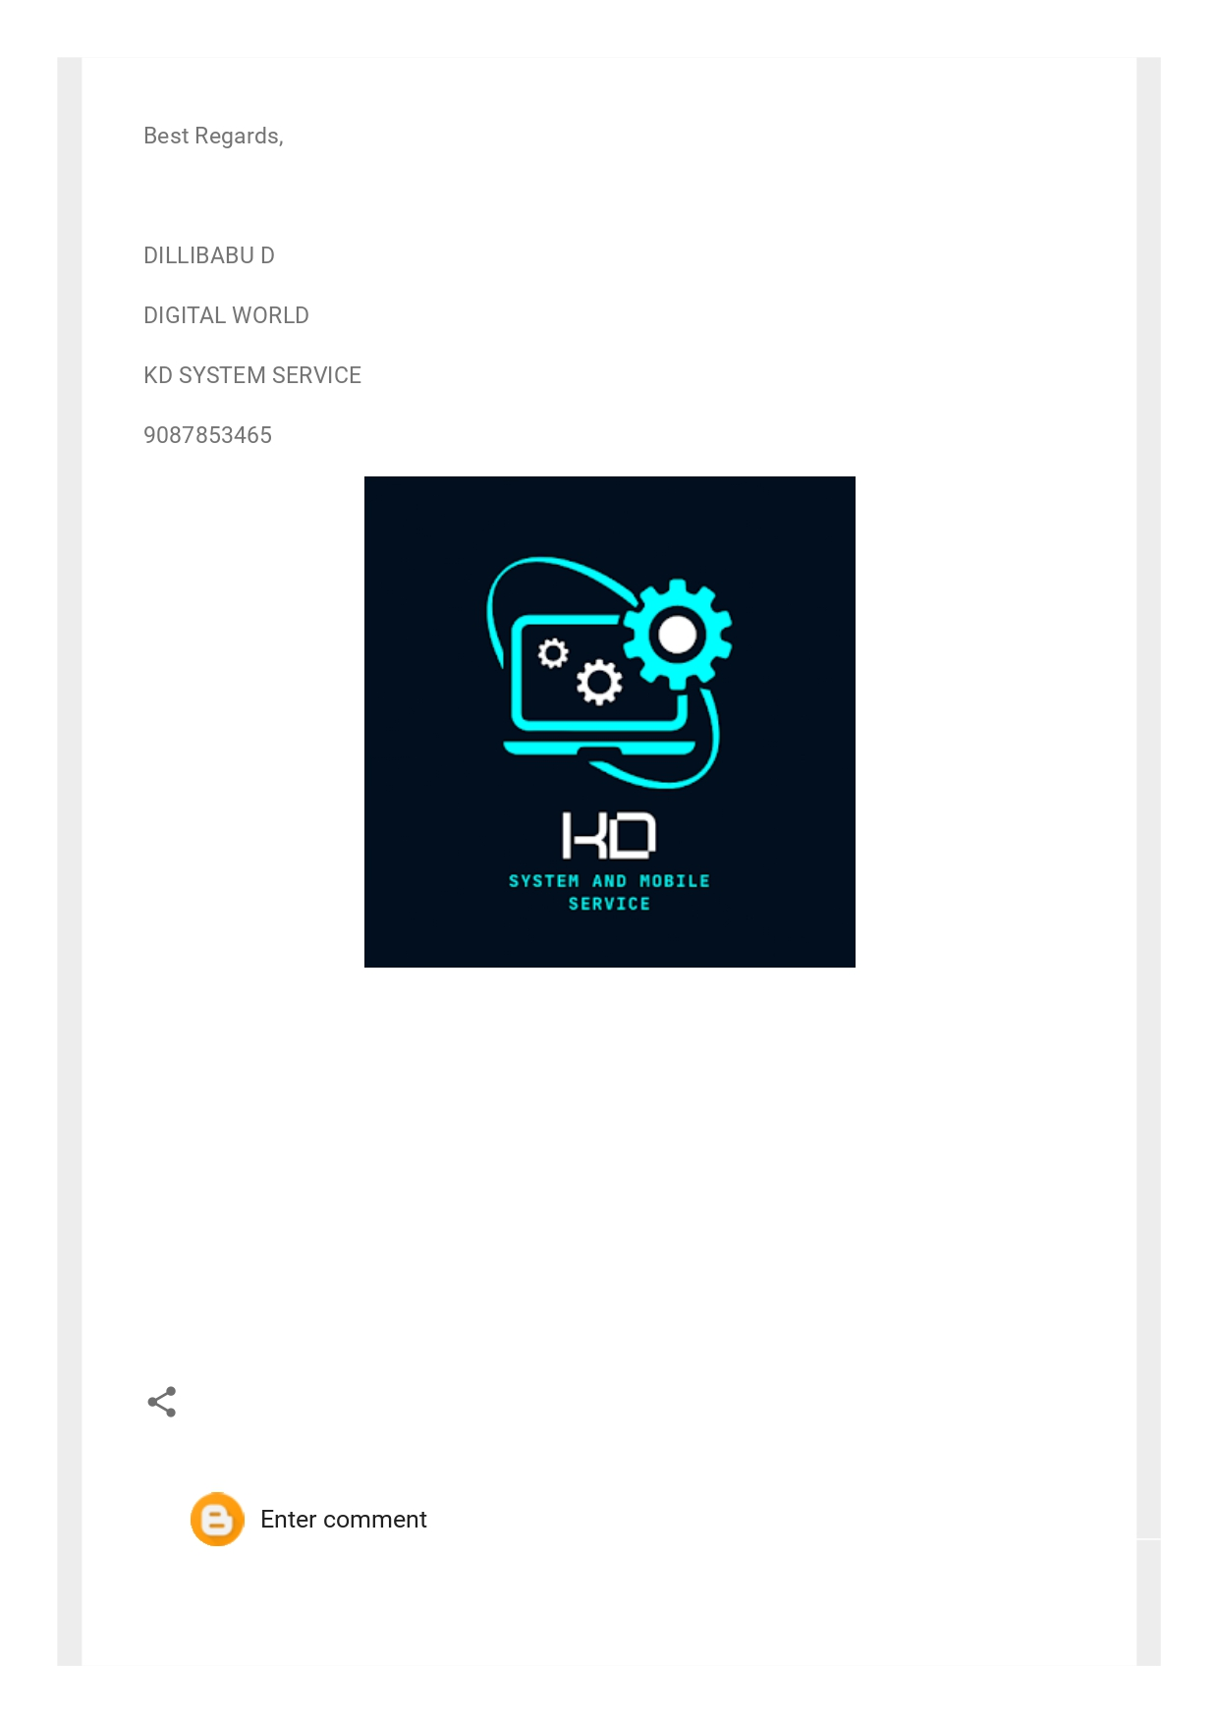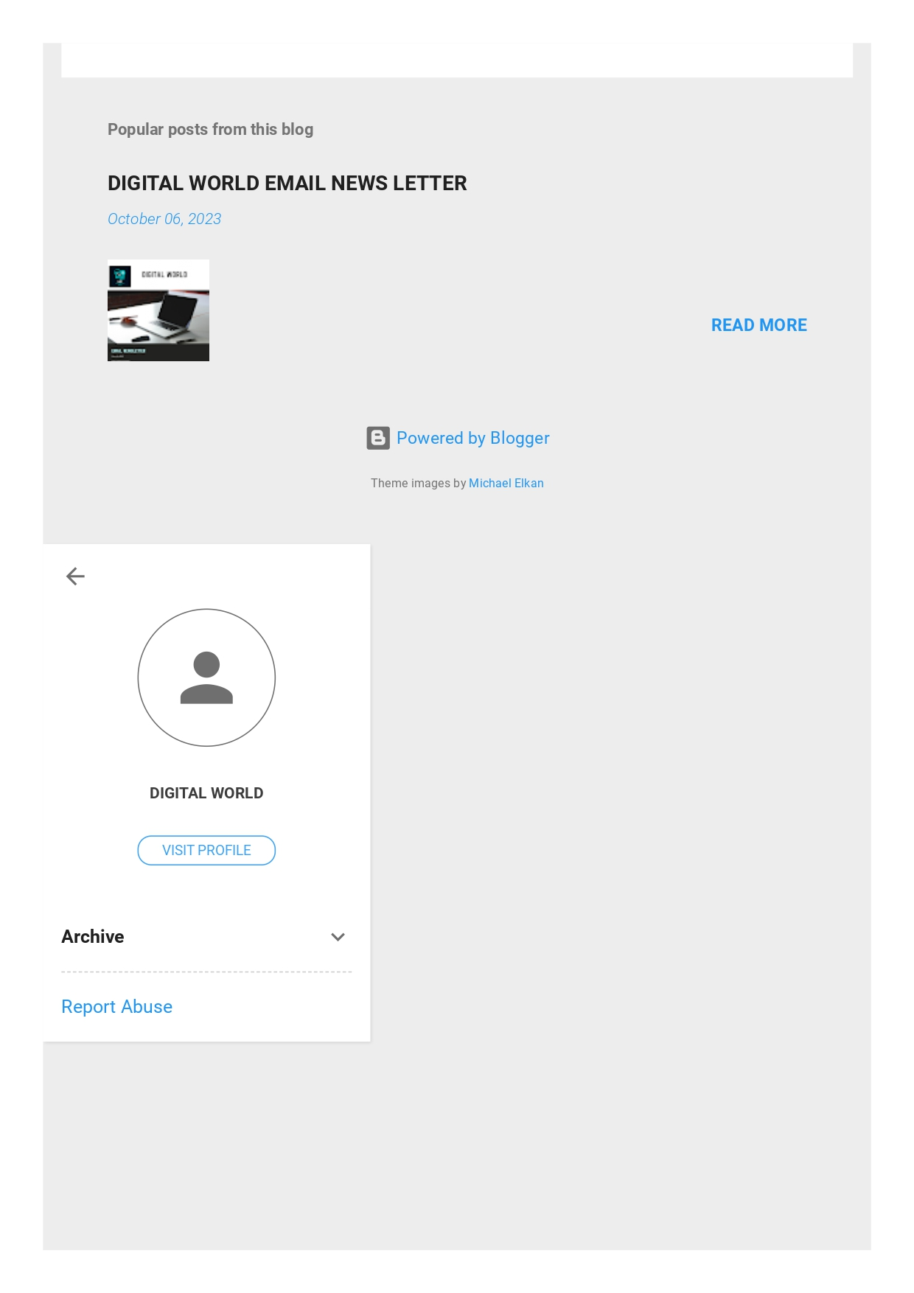

1. Create a New Facebook Business Page and post one social media poster for your brand.

Link: <https://www.facebook.com/profile.php?id=61551344957315>

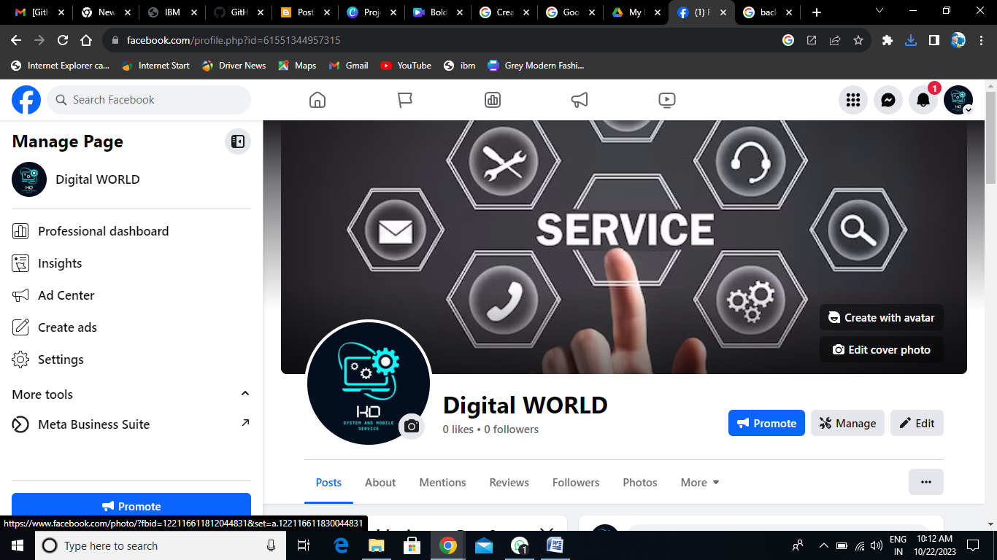

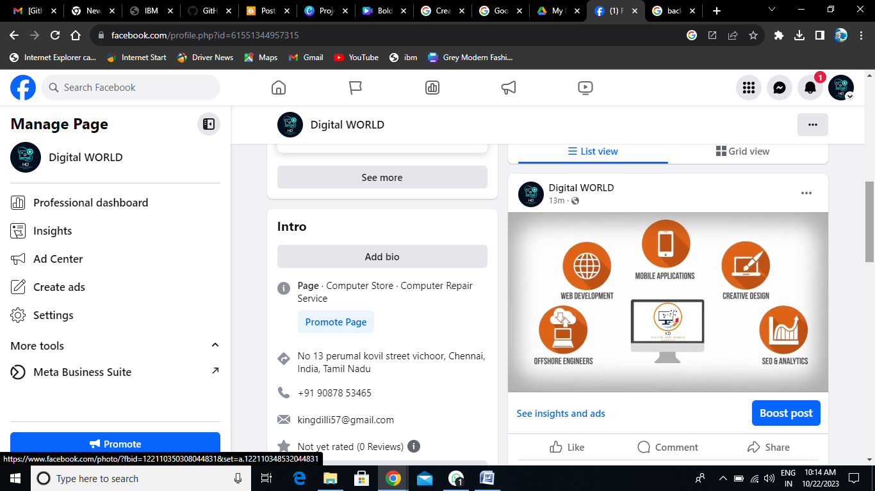

1. Create and design a social media advertisement poster using canva.

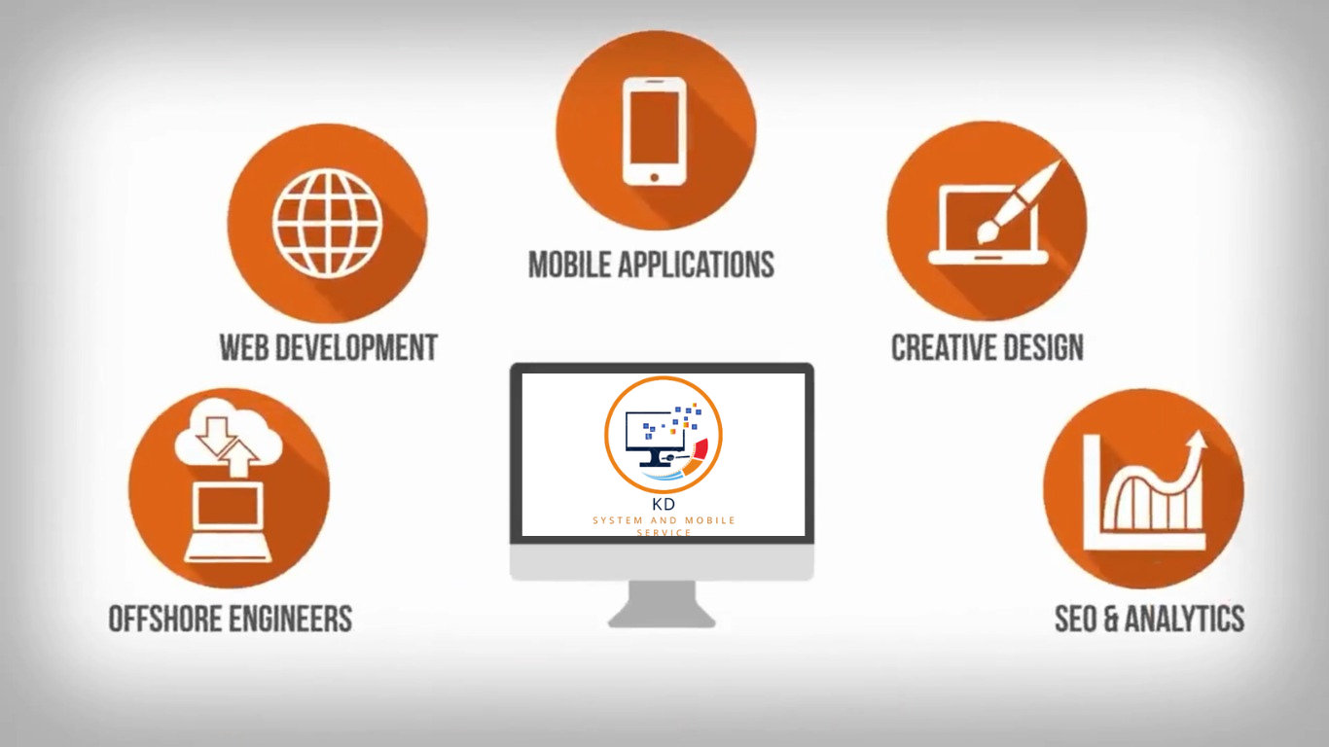

1. Create email newsletter design using MailChimp or canva tool.

Link: <https://digitalworld6002.blogspot.com/2023/10/digital-world-email-news-letter.html>

